application SUPPORT
Date: | July 1st, 2015
Total pages: | 11

Field of interest
● Request: | Application Flat Backs NoHotfix, Flat Backs Hotfix and Sew-on Stones for Dance-sport

information
Following techniques and products are most commonly used for embellishing dancing costumes:

Application technique | products
Gluing | - Flat Backs NoHotfix
Hotfix Application | - Flat Backs Hotfix
Sewing | - Sew-on Articles

- Gluing of Flat Backs NoHotfix on textiles

Flat Backs NoHotfix can be applied onto various textiles and with the usage of a proper gluing system a sufficient bonding between the Crystals and the carrier material is possible.

- Choosing the proper gluing system

Following glues are suggested for application on textile:
  - 3MTM Scotch –WeldTM DP 610 (www.3M.com)
  - Bostik 1475 (www.bostik.com)
  - CHRISANNE (www.chrisanne.com)
  - Hobby Line Schmuckstein Kleber (www.c-kreul.com)
Application tests are advisable to make sure the chosen glue fulfills the specific needs of your application!

- Dosage:

There are different ways to dose the glue. You can either apply the glue directly onto the textile which needs to be covered with Swarovski crystals or you can dose the glue on the reverse side of each crystal one by one using eg. a dosing syringe.
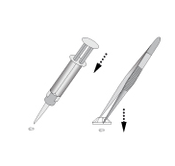
- Setting:
When handling and setting Swarovski crystals, please do not touch the crystals with your fingers! This may pollute the crystal, lower its surface tension and can cause a low bonding strength.
We advise to use tweezers, a wax stick or a vacuum pick-up system to set the crystals. A wax or plasticine stick can be easily made by yourself by applying a small amount of plasticine or wax onto the top of a toothpick.
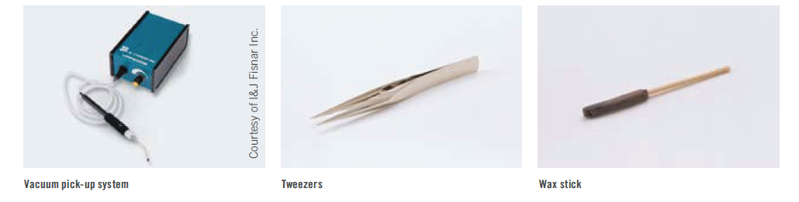

- Post-cleaning and curing:

Excess glue that escapes during setting and pollute the surface of the crystal can be carefully removed using a cotton wipe that has been soaked in a solvent, e.g. isopropyl alcohol. It must be removed while the glue is hardening, as dried glue cannot be fully removed.
Remember to follow the glue manufacturer’s instructions.

The curing time of the glue depends mainly on the temperature. Please note the glue manufacturer’s instructions.

- Applying Flat Backs Hotfix on textiles

Flat Backs Hotfix can be applied simply, quickly and securely onto a wide range of textiles.
To achieve a strong bonding between Crystal and textile, please consider following application advices:

Basic Hotfix Principles
Hotfix elements have a coating of hot-melt glue on the back, enabling swift, simple application. This glue is activated by heat (applied either directly or indirectly via ultrasound), and bonds with the carrier material. When cooling, the glue hardens and securely and permanently fixes the elements in place. The Swarovski Hotfix adhesive is characterized by its wash resistance and easy-care properties. The temperature, application time and pressure can be varied according to the carrier material.

Material check
Before beginning the application process, you should always check whether the carrier material is suitable for Hotfix application. Please check the following criteria:
- Heat resistance (min. 120 °C/250 °F)
- Resistance against pressure
- Application area of the product
- Suitability of surface properties and absorbency

Checking absorbency via the water drop test
The water drop test is a quick and easy way to get an initial idea of the absorbency of the carrier material.
Apply a couple of water drops onto the carrier material. If the material quickly absorbs the drops, it offers good absorbency. If the water pearls off the carrier material, or if it takes a long time to be absorbed, the material offers insufficient absorbency. This can impair the effectiveness of Hotfix application.

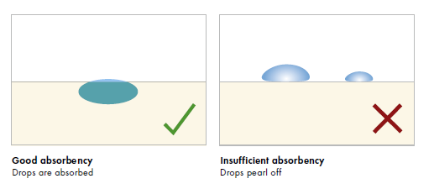
It can sometimes be helpful to wash the carrier material before application, in order to remove any unsuitable finishes (particularly softening agents), and thus improve absorbency.

Temperature
Swarovski Hotfix adhesive is activated within a temperature range of 120 °C to 170 °C (250 °F to 340 °F). A suitable application temperature can be selected from this range according to the carrier material and its sensitivity to heat.
Pressure
The pressure setting depends on the Hotfix elements to be applied, the carrier material, and the technical equipment (machines, etc.) available.
Too much pressure can cause the adhesive to be spread out and can also affect the surface of the carrier material.
Too little pressure, however, can result in a weak and insufficient bond between the crystal and the carrier material.
In general, the pressure should be applied directly to the crystal product. It is therefore necessary to check if there are any buttons, zippers or other raised parts surrounding them.
Application time
In general, the application time should be sufficient to allow the hot-melt glue to be fully activated, and then to penetrate the carrier material.
The application time necessarily depends on the Hotfix elements, the temperature selected, the machine used, the carrier material and the application side.
A detailed summary can be found in the Hotfix Selector table at the end of this chapter. Please note that the times stated are intended as a guideline. When adapting them to your application, it is recommended to carry out tests on the original material.
Application side
Hotfix elements can usually be applied from the front and the back. A shorter application time can be achieved with thinner fabrics by applying crystals from the back, as the heat reaches the adhesive through the carrier material faster, activating it immediately.

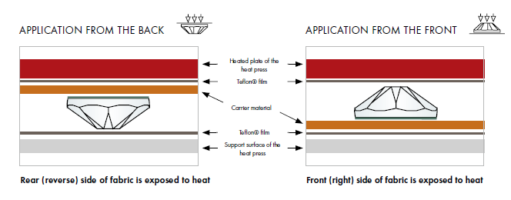
Defining the optimum application parameters
Adhesive has been successfully activated when, using a magnifying glass, it is possible to see a thin edge of glue formed around the crystal. On thin fabrics, the optimum application parameters are chosen when the glue will have lightly penetrated through the fabric and is lightly visible at the reverse.

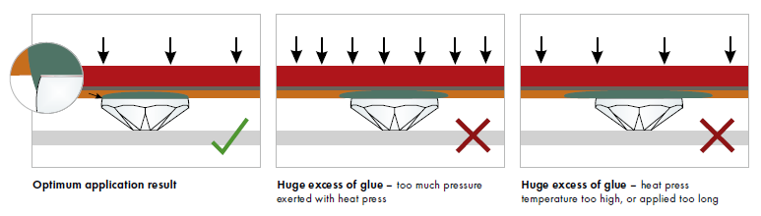

Application machines

For embellishing dance costumes, following machines are mostly used:

- Ultrasonic device

Art. 2078 XIRIUS Flat Back Hotfix (SS 12 – SS 34), art. 2038 XILION Flat Back Hotfix (SS 6 – SS 10) and some Creation Stones (e.g. Rivoli cuts art. 2716, 2816, 2826) can quickly and easily be applied using an ultrasonic device. In this process, the hot-melt adhesive is activated via friction heat, created through the quick vibrations and simultaneous pressing down of the Flat Backs onto the carrier material.
A device with a vacuum pump is best for correctly positioning the crystals. Alternatively, they can also be positioned using transfer film or tweezers, and then applied via ultrasonic.
The frequency of the ultrasonic device must be precisely set according to the manufacturer’s instructions. Some manufacturers also offer devices with automatic frequency setting. The application time is then selected according to pretests.
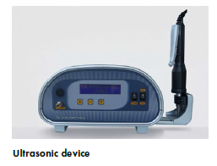
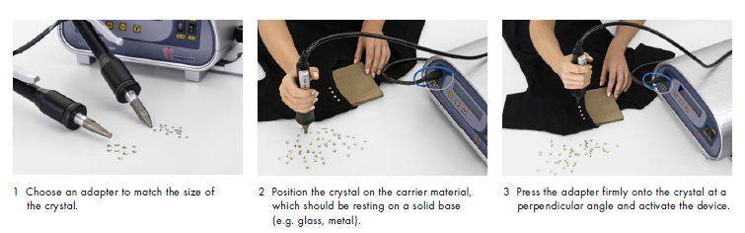

- Stone setting machine
Hotfix crystals can be secured with a stone setting machine using either ultrasonic or heat. The feed and application of the crystals is either fully or semi-automatic.
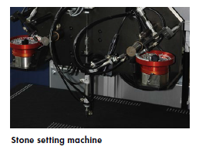

- Heatpress
A heat press is the ideal tool for applying Hotfix products as it can be used to apply even, adjustable pressure.
To adjust the application parameters and the aids to achieve an ideal balance, it is strongly recommended that tests are carried out with the original material.
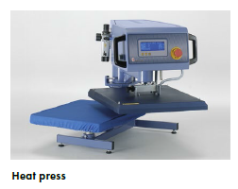
- Applicator
Applicators are a cost-effective way to apply art. 2078 XIRIUS Flat Back Hotfix (SS 12 – SS 34) and art. 2038 XILION Flat Back Hotfix (SS 6 – SS 10) onto the carrier material.
Note: Heat sensitive fabrics can be damaged by high temperatures of the applicator point.
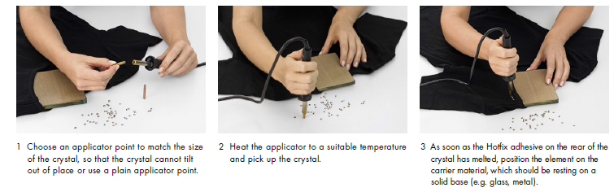
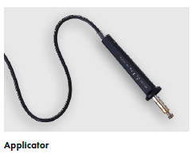

Finding the right application parameters:
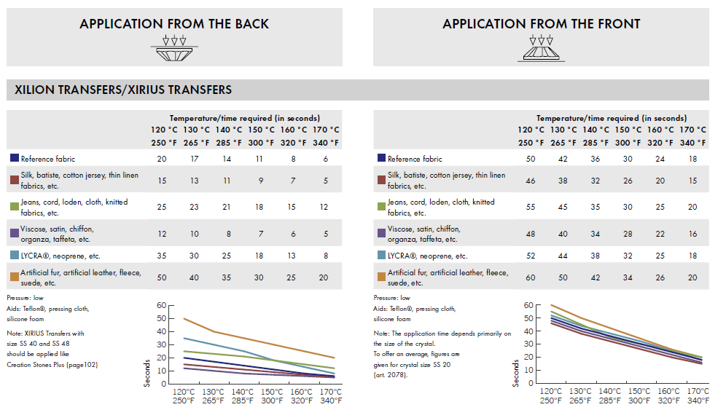

- Applying Sew-on articles

There are many Swarovski products that are suitable for sewing and embroidering. These products can be easily applied either by hand, or with standard domestic or industrial sewing and embroidery machines. Swarovski also offers an ideal selection of products for a variety of creative techniques by hand.

Selecting the optimum thread
When sewing Swarovski products, particularly Sew-on Articles, Crystal Buttons and Beads, synthetic multifilament threads with a thread count of Nm 50 – 80 are most suitable. Monofilament and pure cotton yarns are not recommended due to their limited abrasion resistance.

Machines
Alongside sewing by hand, the following machines, tools, and aids can be used for sewing and embroidering Swarovski products:
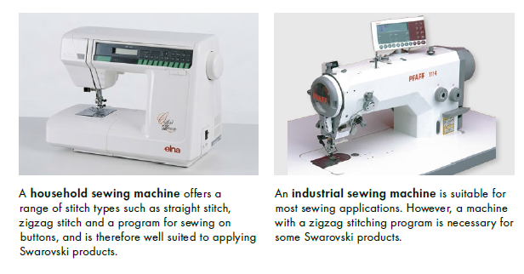
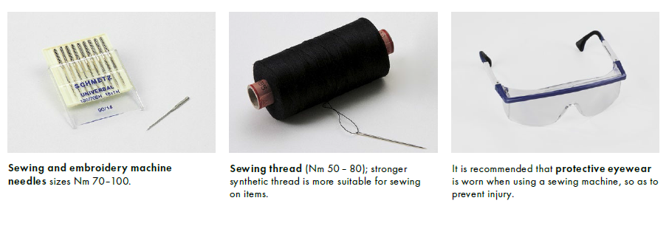
Application using a sewing machine
The right choice of needle (strength Nm 70 – 100), sewing thread and thread tension (upper and lower thread) are particularly important for applications with a sewing machine. The fabric must not become gathered and the upper and lower thread should run easily and smoothly.
Tests should be conducted on the original material before beginning production.
Before sewing on Crystal Buttons with a machine it is essential to set the sewing machine to the correct hole and stitch length, as well as stitch width. This prevents the crystal from being damaged during application and reduces the risk of injury.

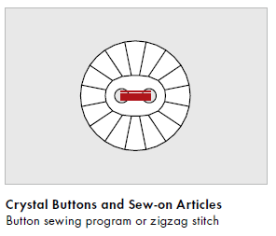
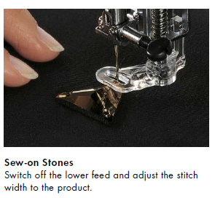

For more detailed application information please visit our homepage:
Application Manual - Swarovski

If you require any further advice or information, please do not hesitate to contact us again.

Best regards,
Swarovski Professional

Please find more information on WWW.SWAROVSKI.COM/PROFESSIONAL and in our Application Manual.

Failure to follow Swarovski’s care instructions may result in damage to the crystal, which could pose a risk of laceration or other harm. Any oral, written or test-based advice that Swarovski provides regarding techniques for application of its products are recommendations based on Swarovski’s current knowledge and the information provided by its suppliers. Such advice does not discharge customer from carrying out its own tests of techniques it proposes to use and their suitability for the intended application. The application, use and processing of these techniques and products are solely user’s responsibility.

